Outputs for Gene Expression done in Python language

- Number of significantly up and down regulated genes based on pvalue and log fold change thresholds.

A vs E :
Number of upregulated genes are: 561
Number of downregulated genes are: 921

A vs F :
Number of upregulated genes are: 627
Number of downregulated genes are: 829

- Summary statistics for pvalue and log fold changes

- A vs E
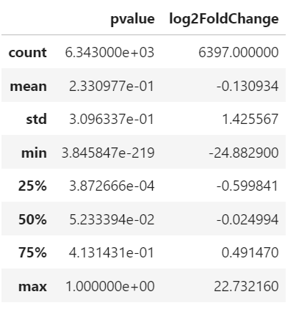
Table 1 Summary statistics for A vs E dataset
based on pvalue and log2FoldChange

- A vs F
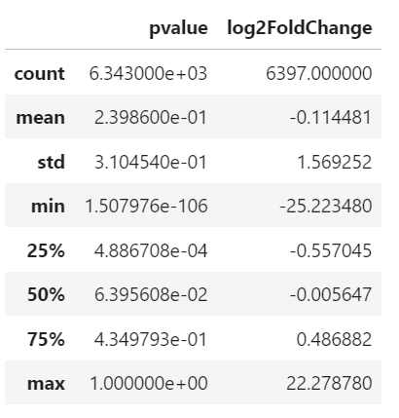
Table 2 Summary statistics for A vs F dataset
based on pvalue and log2FoldChange

2. Volcano plots to visualize the significance and magnitude of changes in
gene expression for each comparison.

- A vs E

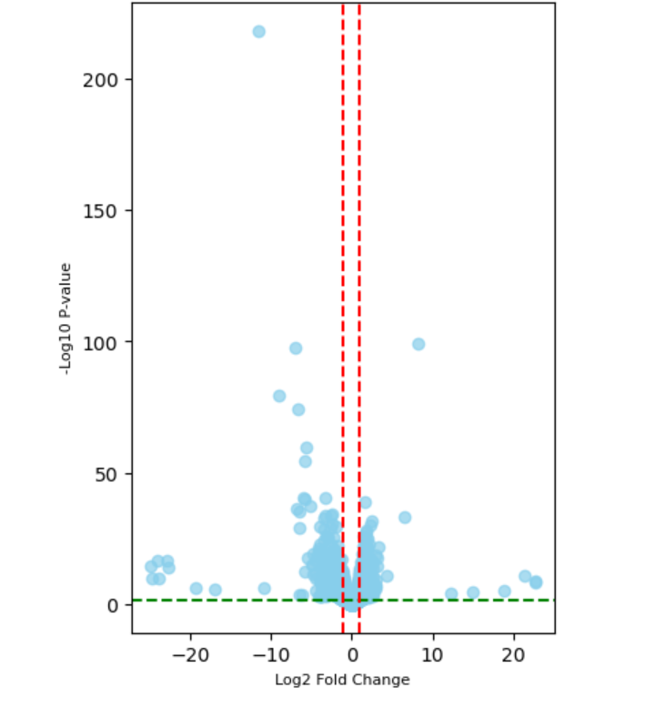
Fig 1 Volcano plot for A vs E to visualise significance
and magnitude of changes in gene expression

- A vs F

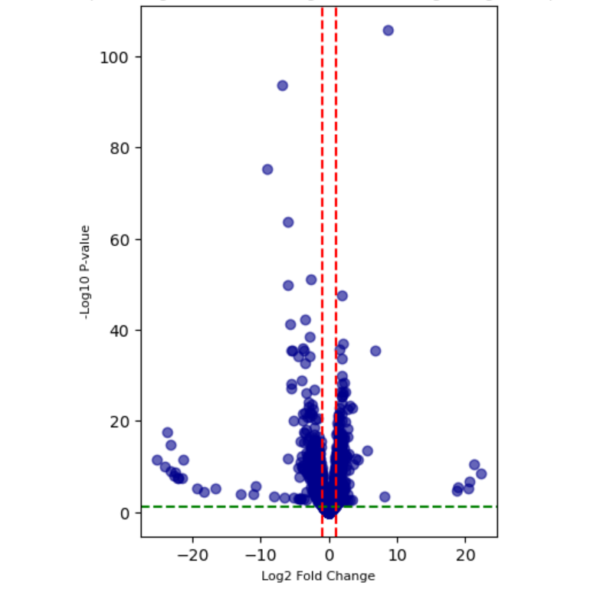
Fig 2 Volcano plot for A vs F to visualise significance
and magnitude of changes in gene expression

3. MA plot to display the relationship between the log fold change and mean
expression.

- A vs E
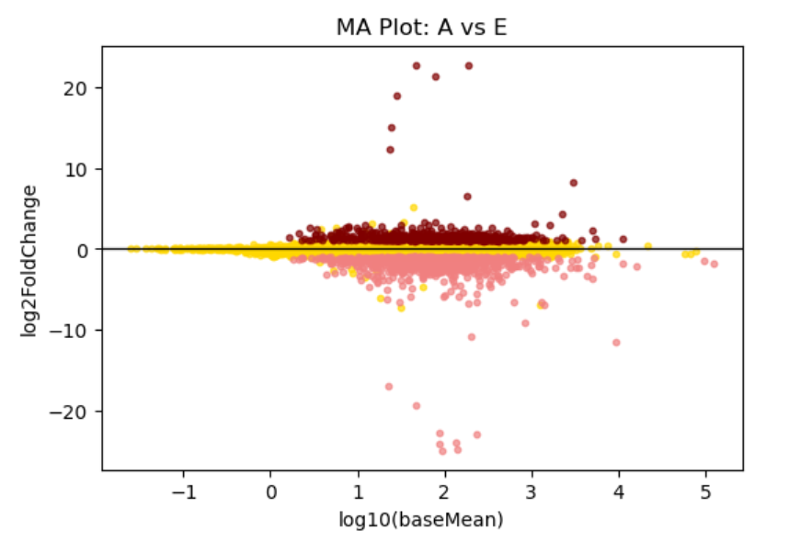
Fig 3 MA plot of A vs E to display relationship between mean expression and log fold change

- A vs F
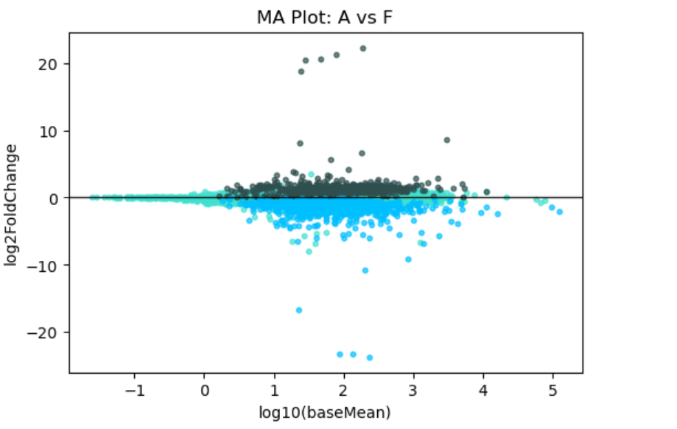

Fig 4 MA plot of A vs F to display relationship between mean expression and log fold change

4. Histogram of p-values to assess the distribution of statistical significance.

- A vs E

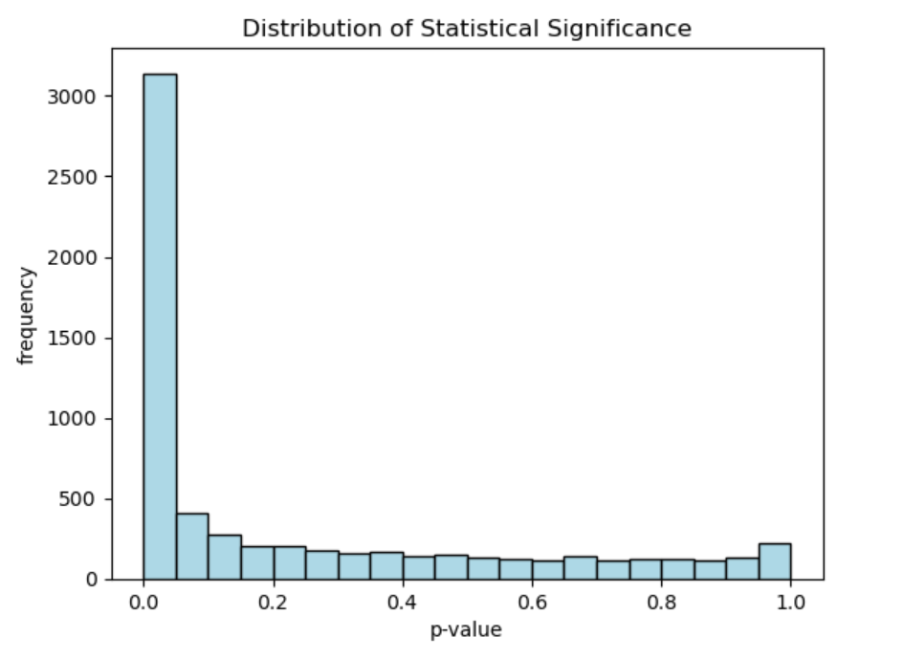
Fig 5 Histogram plot of A vs E to assess the distribution of statistical significance

- A vs F

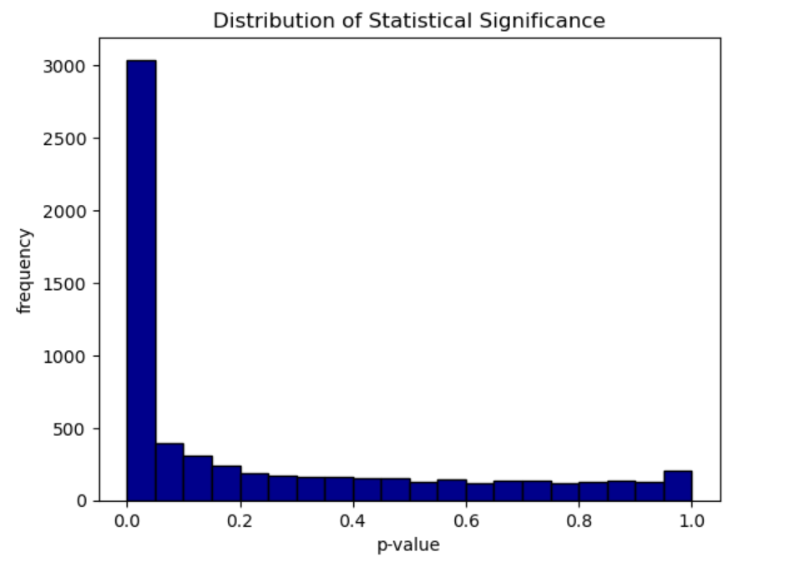
Fig 5 Histogram plot of A vs E to assess the distribution of statistical significance

5. Heatmap of the top differentially expressed genes to illustrate gene
expression patterns across the conditions.

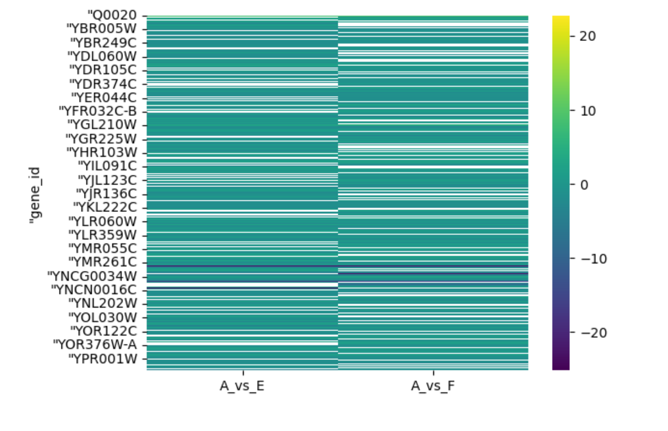
Fig 7 Heatmap to illustrate gene expression patterns across conditions

6. A table or list of significantly upregulated and downregulated genes with their corresponding fold changes, p-values, and adjusted p-values.

A vs E
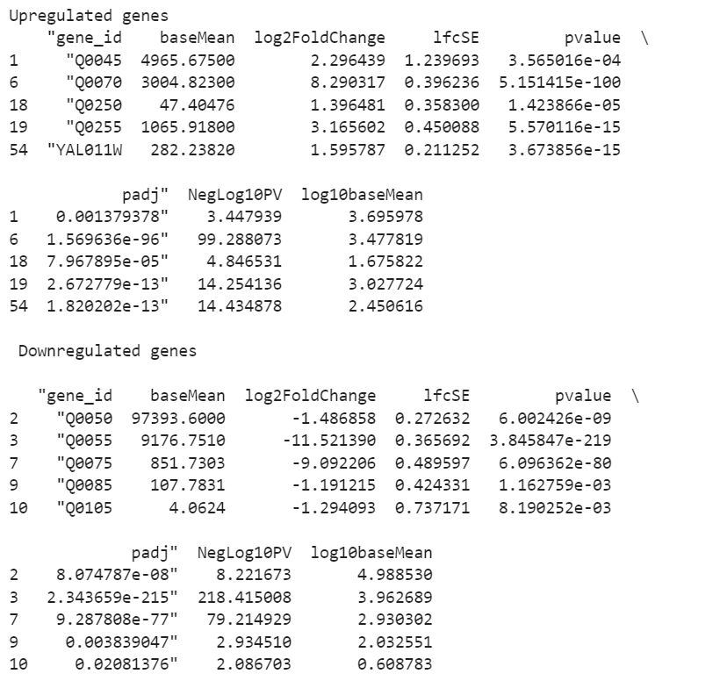

A vs F
